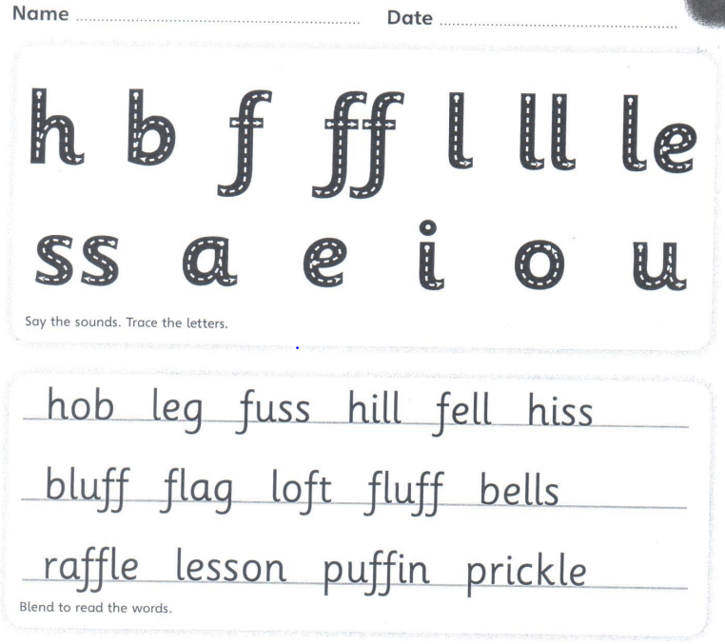

Copy the sentence out
The fussy puffin fell on a prickle in a loft .
____________________________________________________________________
Now can you put lesson into a sentence.
____________________________________________________________________

